Global Studies Name:
Mapping Global Conflicts Section:
Leveled Assessment: _____/4 Score: _____/15

Directions: You will be using the Global Conflict Tracker, ArcGIS, and the National Geographic Website students will be creating a We-Explore Expedition about a current Global Conflict
OPS Students: This Assignment has a x3 multiplier

Current Conflicts
- Al-Shabab in Somalia  - Boko Haram in Nigeria  - Civil War in Libya  - Civil War in South Sudan  - Civil War in Syria  - Conflict between India and Pakistan  - Conflict in Ukraine  - Criminal Violence in Mexico  - Destabilization of Mali  - Islamist Militancy in Egypt  - Islamist Militancy in Pakistan | - Islamist Militancy in Russia  - Israeli-Palestinian Conflict  - Kurdish Conflict  - Nagorno-Karabakh Conflict  - North Korea Crisis  - Political Crisis in Burundi  - Refugee Crisis in the European Union (EU)  - Sectarian Conflict in Lebanon  - Sectarian Violence in Myanmar  - Taliban in Afghanistan | - Tensions in the East China Sea  - Territorial Disputes in the South China Sea  - Uighur Conflict in China  - Violence in the Central African Republic (C.A.R.)  - Violence in the Democratic Republic of the Congo (D.R.C.)  - War against Islamic State in Iraq  - War in Yemen

Part 1: Researching the Conflict
Directions: Use the Global Conflict Tracker by Council on Foreign Relations (http://www.cfr.org/global/global-conflict-tracker/p32137#!/p32137) To research the conflict and answer the following series of questions. As you go along if you need to find information that is not on the website make sure you cite the sources in proper MLA format. As you are going along in your research look for possible geographic data that you could map.
- Type of Conflict: What type of conflict is it and why is it classified as such?

- Human Cost: To date how many people are estimate to have been affected by the conflict?
  - Number of Internally Displaced Persons:

  - Number of Individuals wounded:

  - Number of individuals Killed:

  - Number of people who have fled as refugees:

  - How have the people of the country/region been affected by the conflict?

- Participants: List the groups involved and how they are contributing to the conflict:

- Origins: Since when has the conflict been going on (as specific a date as possible) and what events led to the beginning or expansion of the conflict.

- Concerns: Explain the concerns of the conflict related to the United States, and any potential concerns for regional or global stability

- Conflict Status: Is the conflict worsening, stabilizing, or unchanging? Explain the current status of the conflict and what attempts have been made to stabilize the situation, or any events that have led to increased tensions.

- Impact: What is at stake in the conflict? (Make an argument as to why people should care about what is happening in this conflict) You can make a list for now but this will eventually be a two paragraph explanation.

- Geographic Data
Geographic Data
Points (Specific Cities/Locations)  List any cities/specific locations and the important events that happened there | Areas (Regions or larger locations)  List references to regions and other large areas and explain the importance of them

- Sources: Cite the sources you used in your research and format them in proper MLA format. Use easybib.com to help you if needed. Make sure you signify what information was collected for each source

Part 2: Mapping the Conflict

Step 1: Preparing your Map
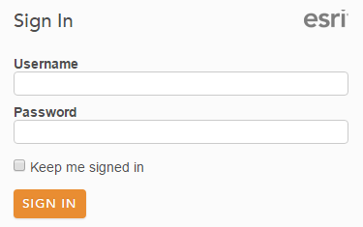
- Sign-in to ArcGIS by going to arcgis.com and left-clicking on the button along the top of the page
- Enter your Sign In information in the box that appears on the righthand side of the page to enter your account
- Use the top menu to navigate to the Map
  - If you already have the map open with information on it then click on the New Map option in the top right of the Map screen and left click Create New Map. This will open a new map without any added features and the default basemap
- Saving your map
  - On the Map page you should already have a blank map, take a moment to save your new project by by left-clicking the Save -> Save as option along the top bar.
  - Give your project a title related to what your map will be showing. You will need to provide at least one tag (ex. School Locations). The summary is not required but recommended
Hint: Save early and Save Often!

Step 2: Adding a Point to Your Map
- Use the search bar in the top right of the map page to find the location of your conflict
- The map should now be centered on your country
- Left click on the option in the top bar and select Add Map Notes
  - Enter in the name of the conflict as the name of the Map Note
- Place a Pushpin on the Map and change the Title of the Pushpin to the name of the conflict
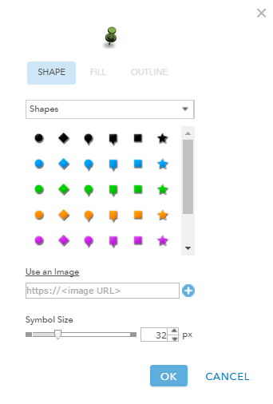
- Customize the Pushpin by Left-Clicking on

- Search the internet for an image of the country’s flag (Google works best)
  - Once you have found an appropriate flag right-click on the image and select Copy Image Address
- Back in ArcGIS in the Pushpin customization menu select Use an Image
  - Paste the Image’s Url by right-clicking on the box that comes up and pasting the url of your image and then left-clicking the button to make the image your new pushpin
    - Make sure the image size is 32 px and then left-click ok
- Change the Visibility of your new point
  - Left-Click on the Details option along the top bar
  - Mouse over your newly create layer and left-click the icon to open up the more options menu for that layer
  - Select the third option titled Set Visibility Range and use the bar to set the visibility of this point from World to Countries (small)
    - Scale setting for Countries (small) should be 1:12,000,000
- Save Your Map

Step 3: Create an Outline for the Country
- Left click on the option in the top bar and select Add Map Notes
- Enter in the name of your country and “outline” (ex. “Syria Outline”) as the name of the Map Note
- Select the Area tool and click along the outline of you country to create a polygon shape of your country
  - Click along the outside of the map along the edge of the border, a straight line will be formed between clicks
  - More complex bordered countries will require more clicks
  - Once you have drawn the polygon the whole way around the country double-click to stop
Note: Be careful clicking on the polygon since it will be very easy to move
- Edit the new polygon
  - Click on the new polygon and change the Name to be the name of the country or region
  - In the Description box write some general information about the conflict
    - What type of conflict it is, who the major parties involved are, and when the conflict started.
  - In the Image URL copy the image address from an image related to the conflict and paste the URL into the space provided
  - In the Image Link URL enter in the URL for the Council on Foreign Relations page for the conflict.
  - Left-Click on Change Symbol to change the Fill Color (inside the polygon) and Outline Color (edge of the polygon) of the new polygon to colors of the country’s flag.
- Change the Visibility
  - Left-Click on the Details option along the top bar
  - Mouse over your newly create polygon and left-click the icon to open up the more options menu for that layer
  - Select the third option titled Set Visibility Range and use the bar to set the visibility of this point from Countries (small) to States/Province
    - Scale setting for Countries (small) should be 1:12,000,000
    - Scale setting for States/Province should be 1:3,000,000
Note: Larger countries may need larger scales
- Save Your Map

Step 4: Create Your Own Layers
- Use the same techniques from Step 2 and Step 3 to add six geographic features to your map from question 8 of Part 1.
- Add at least one Point to the map
  - Give each point a Name that helps explain the event and then a brief synopsis of the event in the description.
  - Set the visibility range of the points from State/Province (1:3,000,000) to Room (1:100)
Note: Points can be any specifically mentioned area (i.e. Cities, battles, etc…)
- Add at least on Polygon to the map
  - Give each polygon a Name that helps explain the event and then a brief synopsis of the significance of the area
  - Set the visibility range of the polygons from State/Province (1:3,000,000) to Room (1:100)
Note: Polygons can be any broad generally defined area
- Save Your Map

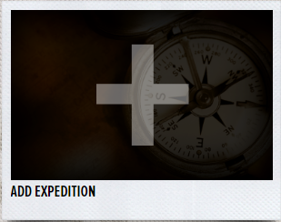
Part 3: Create a We Explore Expedition
- Navigate to https://we-explore.com and Sign-In using the login that was e-mailed to you
- Left-Click on Expeditions along the top bar and take a minute to check out one of the pre-made expeditions to get some ideas for how to organize your expedition
- When ready select Basecamp and create your own expedition by left-clicking on Add expedition
- Create your Expedition
  - Make the Name related to your conflict
  - The Mission should explain generally what your expedition will show
  - Your Question will be what are the major questions
  - Search for the Latitude and Longitude of your country or area and enter that in
  - Put the city that is the at the center of the conflict, or the capital of the country
  - Enter in the name of the country
  - Select the continent your country is in
  - For Category select World
  - Enter in the name of the school
  - Enter in the name of the teacher
  - Add a picture that is a representation of your conflict
  - Make the Expedition Publically Viewable
  - Once finished select
- Add your content
  - Add the information from your research in Part 1 into the expedition. You will need to have at least one page on your expedition for each of the sections (Type of Conflict, Human Cost, Participants, Origins, Concerns, Conflict Status, Impact)
  - Add Multimedia
    - Video: A Short Video (no more than 5-7 min) that helps explain information in one of the 7 Informational Categories (Type of Conflict, Human Cost, Participants, Origins, Concerns, Conflict Status, Impact)
    - Add in your own synopsis of the video and the source of the video in the caption
    - Picture: Two additional pictures that relate to one of the 7 informational categories (Type of Conflict, Human Cost, Participants, Origins, Concerns, Conflict Status, Impact)
    - Embed Map: Add the map that you created in Part 2 to your expedition
      - Sign back in to ArcGIS
      - Open up your map by left-clicking on My Content along the top bar and then select your map you made in Part 2.
Note: If you just select the layer it will only open the map description and you will need to left-click the box on the right side to open the map
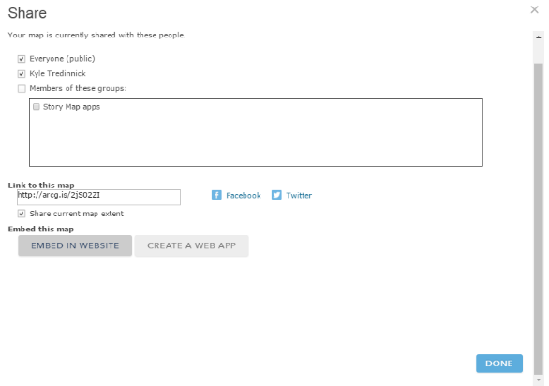
      - Select the option along the top bar of your map to open the share menu
        - Make sure the map is Shared Public by selecting the appropriate boxes
        - Select Embed in Website so that you can include your map in your Expedition
        - Copy the HTML code that shows up in the next box, you should not need to change any of the other options
      - Switch back to we-explore and Add Content and select Map
        - Give the map a Title related to the conflict
        - Write a brief Description of the map
        - For Website select Use Embed and paste the HTML code you have just copied from ArcGIS
        - Once it is set up the way you wanted select
  - Add your sources
    - Include your bibliography in a Note on we-explore
      - The Global Conflict Tracker from the Council for Foreign Relations should be on there
Stares, Paul B. "Global Conflict Tracker." Council on Foreign Relations. Center for Preventative Action, 2016. Web. 31 Jan. 2017. <http://www.cfr.org/global/global-conflict-tracker/>.
      - You need to Include at least one source from National Geographic (print or online library)
      - Cite the sources of your pictures and video
Last, First M. Photograph Title. Year Created. Photograph. Museum/Institution, Location. Website Title. Web. Date Month Year Accessed.

Mapping Global Conflicts Grading Rubric
Score (Level Achieved) | Visuals | Information | Embedded Map | General Design | Questions | Productivity
0 (Not Shown) | No additional visuals added to expedition | No informative text added to expedition | No evidence of attempt to complete map | No attempt to make an expedition about the topic | Less than 25% of questions attempted, or completed correctly. | Project not completed
1 (Attempted) | Some visuals added, but less than the required number or some visuals do not connect to the objective | Some informative text added to expedition, but more needed to properly address objectives | Map construction is attempted, but is missing data layers, or is unreadable | Expedition started, but missing large amounts of information. Lack of organization makes expedition confusing | Most questions attempted, but more than half are incomplete or incorrect | Project attempted, but far from complete before given deadline.
2 (Basic) | Required number of visuals added, but some do not connect to the ideas of the expedition or lack captions | All questions answered, but some answered more completely than others. Some answers lack clarity or depth | All of the elements of the map are present, but have not been refined making data difficult to read. | Most expedition elements present, but organizational or design errors make expedition goals hard to understand | More than half of questions are completed and correct, but lack depth of understanding and analysis | Project not completed by the required deadline. Worktime not well utilized resulting in needing extra time
3 (Acceptable) | Proper amount and use of visuals, but some small errors in captions or explanations | Informative text is clear and helpful in understanding objective. Sources cited where necessary. Some errors in grammar or missing information | Evidence in effort to display data. All data sets are clear and understandable. Still some small errors, such as layer order, transparency, pop-ups, or symbology. | Expedition contains all of the necessary elements, but edits needed in content, visuals, explanations, or organization | All questions completed and most questions answered correctly. Only a few questions lack full analysis. | Project mostly completed, with some errors present requiring resubmission. Work time well utilized.
4 (Advanced) | All visuals added with clear understanding of how they connect to objective without errors | All objectives clearly and professionally met by thorough informative text | Map contains all data in clean, easy to read format. Clear attention to details of making a professional map. | Expedition is well done and professional. All elements are present and well organized. | All questions are completed correctly and show clear comprehension of concepts | Project fully completed on, or before, given timeframe. Worktime well utilized with clear regards to deadline.

